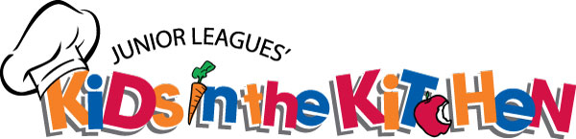

PARENTAL CONSENT FORM

I, ____________________________________________________________________________
Parent or guardian
Agree to allow _______________________________________________________ take part in the
Name of child
Kids in the Kitchen, at Pueblo Community College on February 17, 2018.

IMPORTANT NOTICE
Although Kids in the Kitchen educates children about nutrition, kitchen safety, reading food labels and food substitutions; it is not a project, which provides the type of training in recognizing symptoms of anaphylactic shock, injecting antidotes through Epi-pens or educating children on cross-contamination. Therefore Junior League of Pueblo will not register or be responsible for children who have potentially fatal allergies.

Please complete the following sections, listing any special health or dietary concerns for your child.
GRADE: ________ AGE: ________

FOOD ALLERGIES: ____________________________________________________________
FOOD RESTRICTIONS: ________________________________________________________

Note: This portion of the consent form MUST be signed in order for your child to participate in the Kids in the Kitchen project.

SIGNATURE OF PARENT/LEGAL GUARDIAN: DATE:

HOME PHONE NUMBER: ZIP CODE:

WORK PHONE NUMBER:

EMAIL ADDRESS: ______________________________________
Yes, please email information about other Junior League Events.
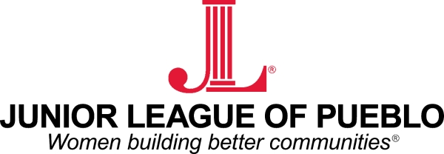

MEDIA CONSENT FORM

CONSENT FOR SPECIFIC PHOTOGRAPHS AND/OR MEDIA COVERAGE

Dear Parents/Guardians:

Representatives from the Junior League of Pueblo would like to photograph your child/family during the Kids in the Kitchen project being held February 17, 2018 at Pueblo Community College. The purpose of this request is to photograph participants taking an active role in the Kids in the Kitchen project. All photos will become part of the Junior League of Pueblo’s database, and may be adapted for other educational or non-educational applications, productions, broadcasts, publishing’s, exhibits and/or distributed in various media formats to a number of markets.

These photos and displays could be shown on power point presentations, the Junior League of Pueblo website, and newspaper and magazine articles relating to the Kids in the Kitchen project, public speaking engagements and any other venue used to create awareness for the Kids in the Kitchen project.

The Junior League of Pueblo cooperates with its partners and the media to encourage celebration of achievements and the sharing of information regarding available programming for children. However, we recognize that there could be instances where Parents/Guardians may not wish to have their child photographed or recorded.

CONSENT FOR RELEASE – PARENT OR LEGAL GUARDIAN

I, being the Parent/Legal Guardian of the participant named below, have read and understand the information provided on this form. I voluntarily give the Junior League of Pueblo my permission to include my child in the photograph/media coverage and its subsequent use as identified above.

NAME OF PARTICIPANT (PLEASE PRINT): __________________________________

NAME OF PARENT/LEGAL GUARDIAN (PLEASE PRINT): __________________________________

SIGNATURE OF PARENT/LEGAL GUARDIAN: __________________________________

DATE: __________________________________

